|  |  |
| --- | --- |
| Source id | URL |
| 77078099 | https://journals.ametsoc.org/view/journals/bams/105/3/bams.105.issue-3.xml |
| 77132099 | https://journals.ametsoc.org/view/journals/clim/37/8/clim.37.issue-8.xml |
| 77142999 | https://journals.ametsoc.org/view/journals/atsc/81/3/atsc.81.issue-3.xml |
| 77260799 | https://journals.ametsoc.org/view/journals/mwre/152/4/mwre.152.issue-4.xml |

The above website has same structure if website.

5)Capture Month.Please capture full word

Ex: Mar=March

1)Go to the website using URL.So you will direct to the current issue page like below

8)Capture article title and click

7)Capture page range

6)Capture DOI

3)Capture issue

4)Capture year

2)Capture volume

You will direct to the article page like below.

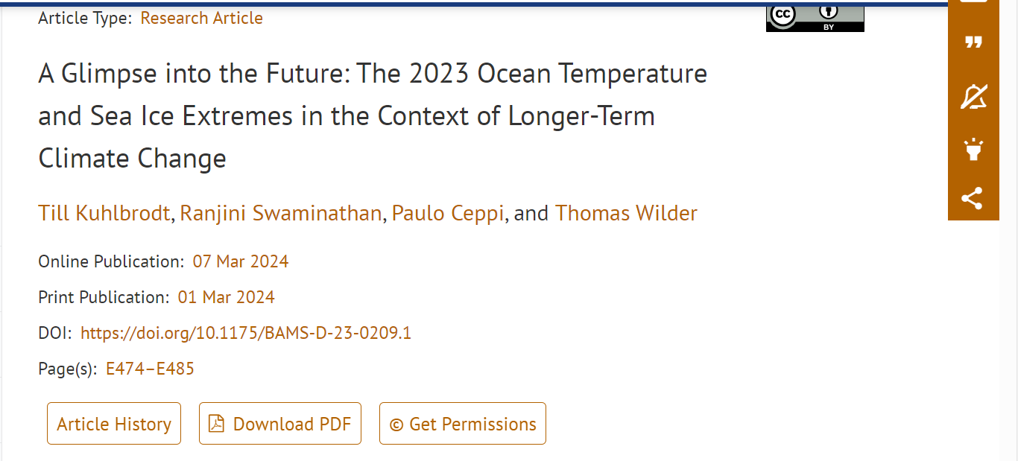

8)Click here to download the page